Question 1

Write the program for deleting an element from the beginning and from any position.

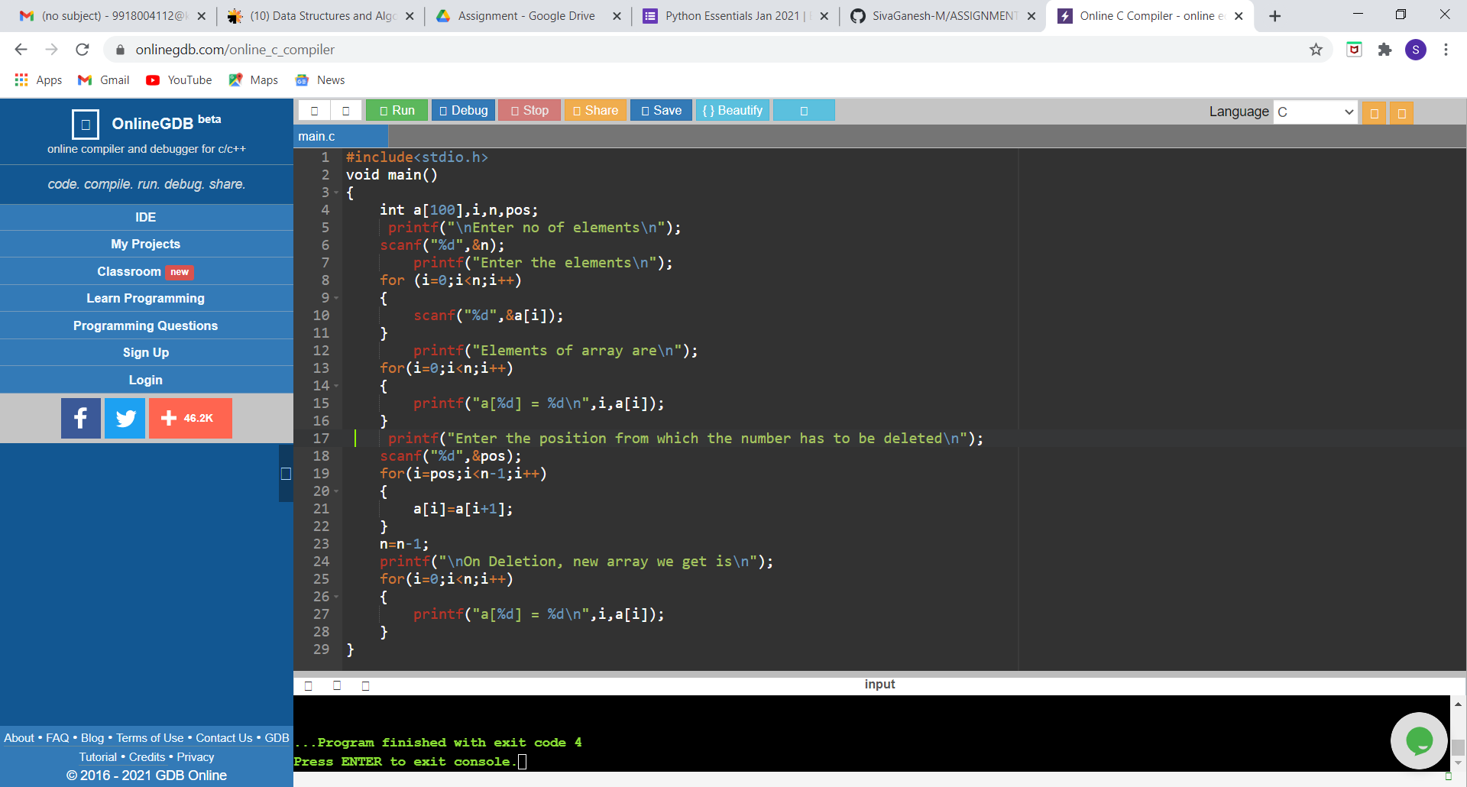

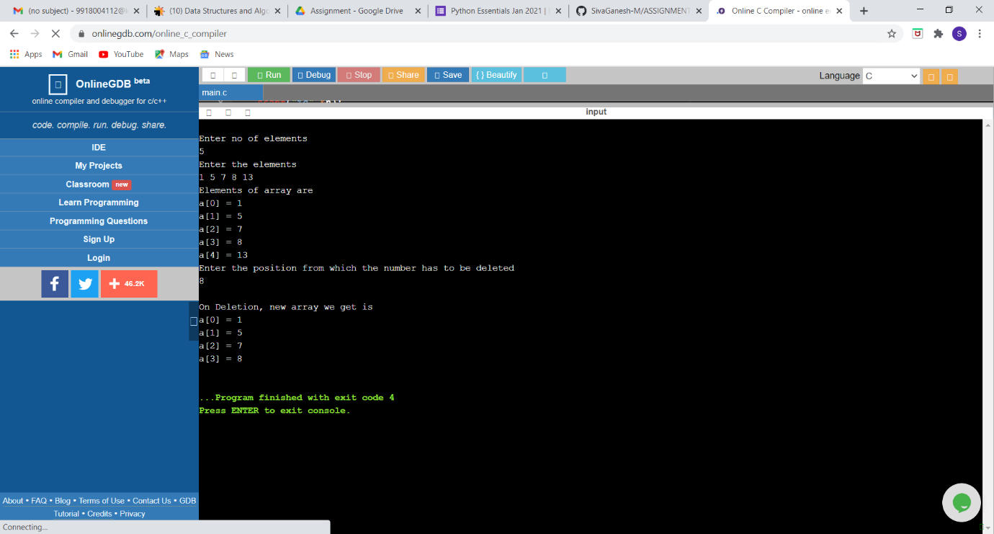

Question 2

Write the program for printing the array after rotating it k times towards left, where k would be taken as user input.

